Task 4
Practice task
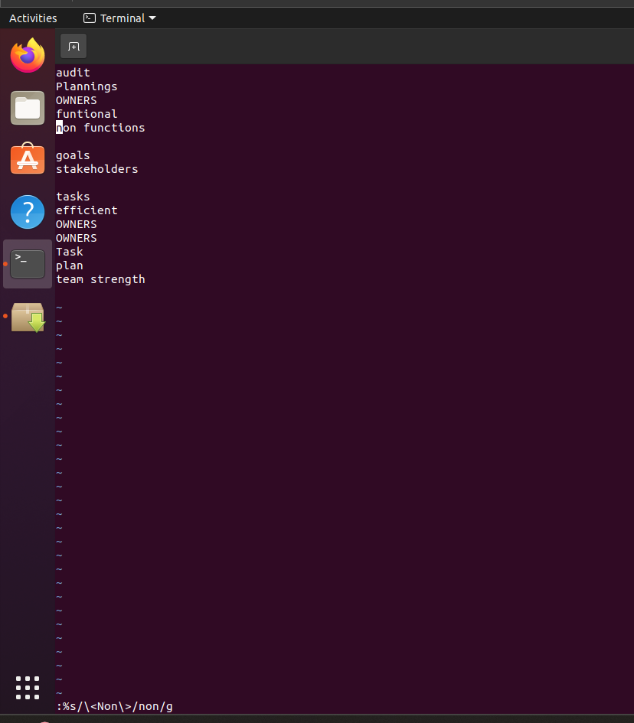

Additional tasks
1. What is the difference between more and less command
Difference between more and less command
Both more and less are used to view large files one screen at a time in the terminal. The more command allows only forward navigation, meaning you can scroll down but cannot easily go back. In contrast, the less command is more advanced and flexible, allowing both forward and backward navigation, searching within the file, and smoother scrolling.

2.In the vi editor, how to delete the character in forward direction?
x → deletes the character under the cursor (forward deletion).
3.In the vi editor, how to delete the character in backward direction
X → deletes the character before the cursor (backward deletion).
4.In the VI editor, how do you search and replace an exact word pattern?
Example text: good morning goodmorning good
Write a command so that only the exact word good is replaced, and goodmorning should not be affected.
%s/\<exactwordpattern\>/replacepattern/g


